Covid-19 Software/Website using Flutter

**Design**

Design References:

1. Youtube - The Flutter Way (<https://www.youtube.com/watch?v=_uOgXpEHNbc&list=WL&index=6>)

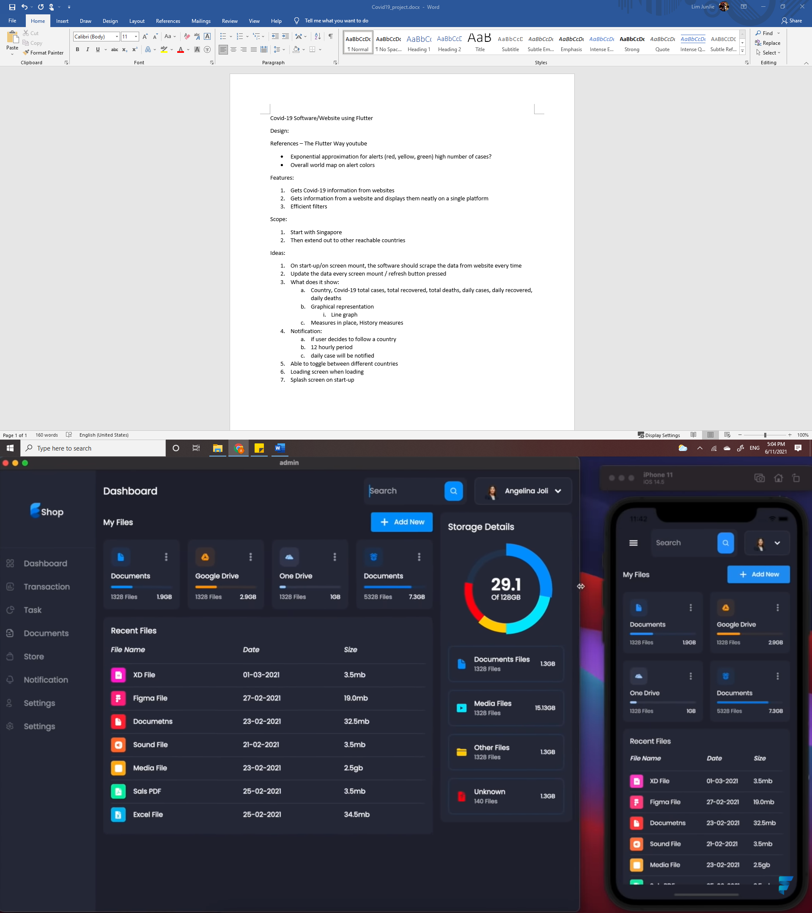

1. Microsoft Power BI

(<https://docs.microsoft.com/en-us/power-bi/create-reports/service-dashboards-design-tips>)

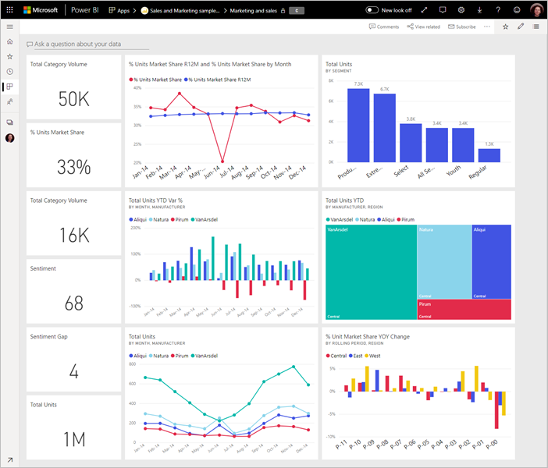

* Exponential approximation for alerts (red, yellow, green) high number of cases?
* Overall world map on alert colors

My Design:

**Features**

1. Gets Covid-19 information from websites
2. Gets information from a website and displays them neatly on a single platform
3. Efficient filters

**Scope**

1. Start with Singapore
2. Then extend out to other reachable countries

**Ideas**

1. On start-up/on screen mount, the software should scrape the data from website every time
2. Update the data every screen mount / refresh button pressed
3. What does it show:
   1. Country, Covid-19 total cases, total recovered, total deaths, daily cases, daily recovered, daily deaths, vaccination rate
   2. Graphical representation
      1. Line graph
   3. Measures in place, History measures
4. Notification:
   1. if user decides to follow a country
   2. 12 hourly period
   3. daily case will be notified
5. Able to toggle between different countries
6. Loading screen when loading
7. Splash screen on start-up